Type-C To 3.5mm Stereo Phono Adapter
Connect your existing phono only headphones or speakers to your
computers or devices that don't have an existing phono port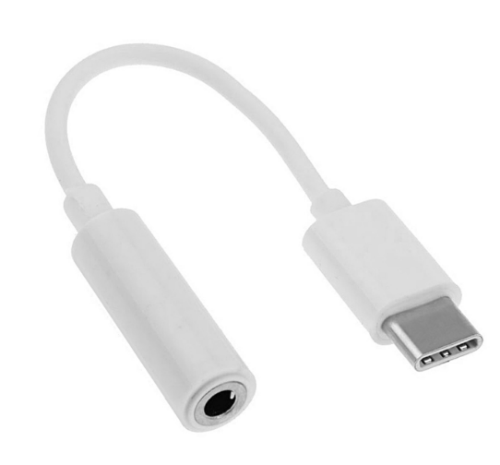

Descrption:
Have a MacBookTM, WindowsTM device or any other compatible, USB-C only computer that does not have a built-in, 3.5mm stereo phono jack?

Simply plug the stereo phono adapter to any free, Type-C port and connect your existing stereo headphones, speakers etc and enjoy full, stereo sound. Plug n' Play without any drivers. Small, stylish and ideal for Hi-Fi sound on your Type-C only device.

Features:

Phone Dongle: this one has DAC digital to analog converter chipset support voice calling and functional button available on your earphones or headphones

Music and Calling– High Resolution support max 96KHz / 24 bits for DAC. Max 48KHz /16 bits for ADC sampling rate Noise reduction technology can improve your sound quality.

Compatibility – Highly compatible for Google Pixel 3/3XL/2 / XL, Essential Phone PH-1, for Apple Macbook Air, Google Chrombook Xiaomi 6, Huawei P20, Mate 10 Pro and other type C devices.

NOTE: Before purchasing, please make sure that the phone model matches the adapter.

Compatible with Xiaomi 6, Xiaomi 6x, Xiaomi 8, Xiaomi 8SE, Xiaomi MIX2, Xiaomi MIX2S, Xiaomi Note3, Huawei Mate10 Pro, Huawei Mate10, Huaeri Honor 10, Huawei Honor V10, Huawei P20 Pro, Huawei P20, Huawei Hornor Play, Huawei Mate RS, Google Pixel, Google Pixel XL, Goolge Pixel 3, HTC U11, HTC U11 PLUS, HTC U12+, HTC M10, LG V30+, NOKIA 8 Sirocco,NOKIA 7,NOKIA 8, NOKIA 7 PLUS,Sony Xperia XZ1, Sony Xperia XZ Premium, Sony Xperia XZ2, Lenovo Z5, Samsung Galaxy S8+, Nubia Red Magic, Nubia Z18Mini, Razer

Specifications
- Material: ABS Plastic
- Cable Length: 80mm
- Color: white
- Port : DC 3.5MM
- Certificate: CE FCC ROHS
- Operating Temperature:0℃ to +45℃
- Operating Humidity:10%0 to 85 % RH
- Storage Temperature : -10℃ to +55℃
- Storage Humidity: 5% to 90 % RH

Product Code:
Part number: C-TC-AUX
Barcode: 8400800036698
Size: 10mm x 80mm x 7mm
Weight: 0.040 kg

